Laptops at St Hilda’s Collegiate School

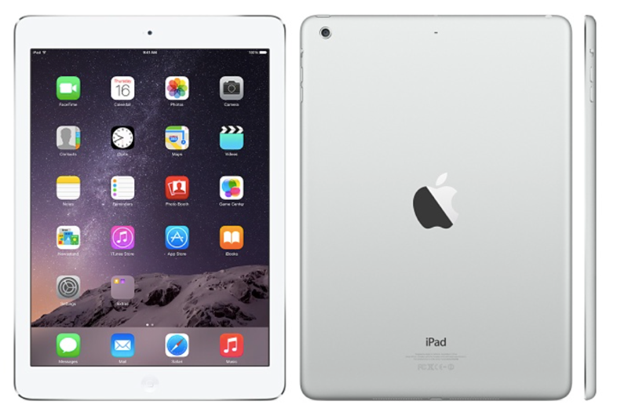

Year 7 and 8 students will be expected to use an iPad at school.
The recommended iPad for St Hilda’s is an iPad – Wifi 32GB Gigabyte or greater. Or greater means more memory. 64GB is preferable as it allows more storage space.
Other options are an iPad Air or iPad Pro 64GB or greater.
We have arranged a purchase option for students at St Hilda’s through Cyclone Computers. Other iPad options are also available through Cyclone. Information is available by visiting the Cyclone website using the details below.
Purchasing Process:
Please visit the Cyclone online ordering site to view prices and make a purchase. The address is: https://byod.cyclone.co.nz/school/index
Cyclone Computers contacts are:
Jane Allen - jane.allan@cyclone.co.nz 03 260 2092
Notes:
Students will need their own Apple ID to access free Apps and other materials. Currently Apple do not allow users under 13yrs of age to have Apple ID accounts unless they are set up through Apple ID Family Sharing.
Information here: Apple ID Family Sharing
Every new iPad gets (free) Apple apps assigned to it through the Apple ID

When setting up an account pay special attention to any security questions and details (including birth date). If these are forgotten in can be a major hassle to recover information and you may get locked out of the Apple ID. Keeping a record is recommended.
Accounts can be set up without a credit card – see this help sheet from Apple – Click here
Managing your iPad
There are no bulk charging facilities for iPads at school as battery life on an iPad is one of its strong points.
iPads should be charged at home each night. Heavy use with such activities as video and music will drain the battery quicker. Please start each day fully charged.
Apple have information about iPad batteries and how to look after them. Available here.
A cover of some sort if highly recommended – either a good neoprene cover or an attached cover that protects the screen.
Setting up ‘Find My Mac’ is also important so the device can be ‘found’ if lost or miss- placed. This involves setting up an iCloud account and downloading the Find My Mac app from the App Store. Information on the set-up can be found here.
Your iPad can be backed up through iTunes or via iCloud.
NOTE: iPads have limited storage. Loading lots of music, photos, games and video will use this space. At school the iPad is primarily a device for Education and space needs to be kept for this. iPads should not contain material that is unsuitable for the school environment as per the school Internet agreement.
Your daughter should add a 4 – 6 digit passcode to access the device so others may not use it if left lying around – although its whereabouts should be monitored by the owner. Safe storage space is available next to the Year 7/8 classrooms.

